**How to use Analysis in LoadRunner**

The **Analysis component in HP LoadRunner** is used to analyze the results from the load test. The Analysis components provides numerous graphs which can be used to understand the results of the load test conducted. In this section of the tutorial , we will see in detail how we can use the Analyze component.

In this tutorial, you will learn:

1. [How to use the analysis](http://setskill.com/hp-loadrunner/how-to-use-analysis-in-loadrunner/#how_to_use_the_analysis)
2. [Types of analysis graphs](http://setskill.com/hp-loadrunner/how-to-use-analysis-in-loadrunner/#types_of_analysis_graphs)
3. [How to view the scenario settings](http://setskill.com/hp-loadrunner/how-to-use-analysis-in-loadrunner/#View_the_Scenario_Settings)
4. [How to export results to HTML](http://setskill.com/hp-loadrunner/how-to-use-analysis-in-loadrunner/#Export_Results_to_HTML)
5. [How to merge graphs](http://setskill.com/hp-loadrunner/how-to-use-analysis-in-loadrunner/#how_to_merge_graphs)
6. [How to save a session](http://setskill.com/hp-loadrunner/how-to-use-analysis-in-loadrunner/#how_to_save_a_session)
7. [How to open an existing session](http://setskill.com/hp-loadrunner/how-to-use-analysis-in-loadrunner/#open_an_existing_session)

**How to use the analysis**

If you have an existing Analysis file, you can open the Analysis application and browse for the analysis file.

When the HP suite of testing tools is installed, you can see the Analysis icon as part of the installation.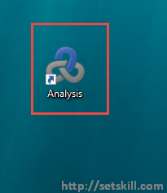

Double click the Analysis to start the application. When the application launches, you will get the below main window to work with.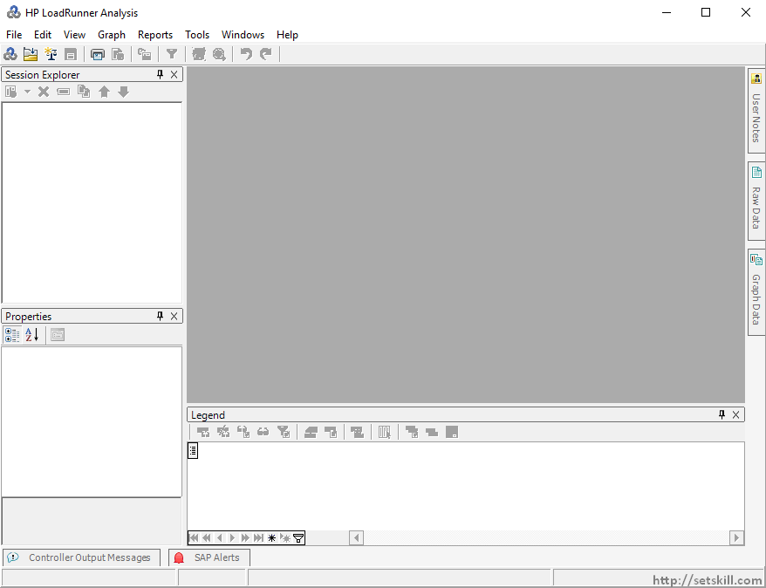

From here, you can use the File menu option to browse for the Analysis file.

Another way to use the Analysis and probably the most common way is to open the file from the Controller after the load test is completed.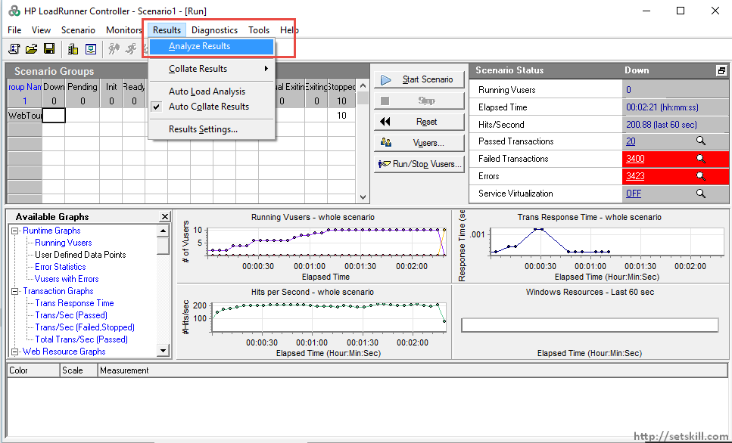

When the load test in the Controller is completed, you can use the File menu option Results->Analyze Results. This will then open the Analysis application and load the results automatically as shown below.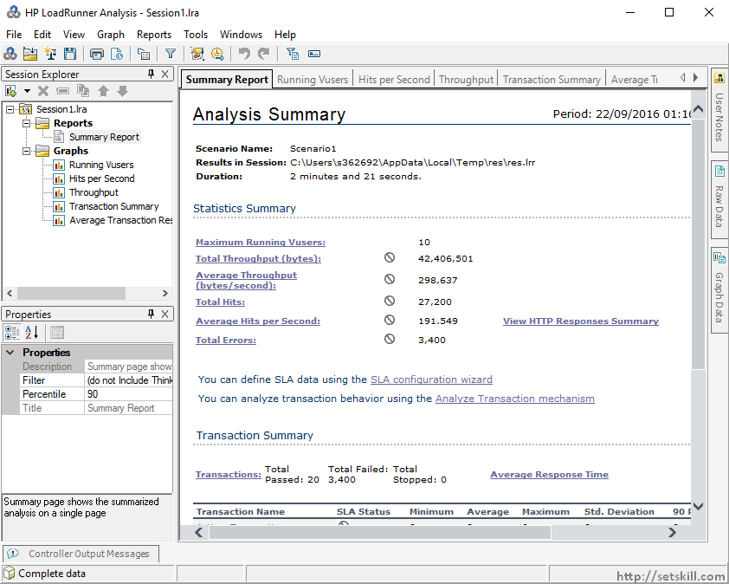

Now let’s go through all the graphs that the Analysis application has to offer.

**Types of analysis graphs**

**Summary Report**

The summary report gives you key information on the overall summary of the load test results. Over here you can view the below mentioned information.

1. The maximum number of virtual users that ran in the test
2. The number of bytes which were transferred to the application.
3. The number of bytes which were transferred to the application per second.
4. The total number of hits to the application
5. The total number of hits to the application per second.
6. The number of errors encountered in the application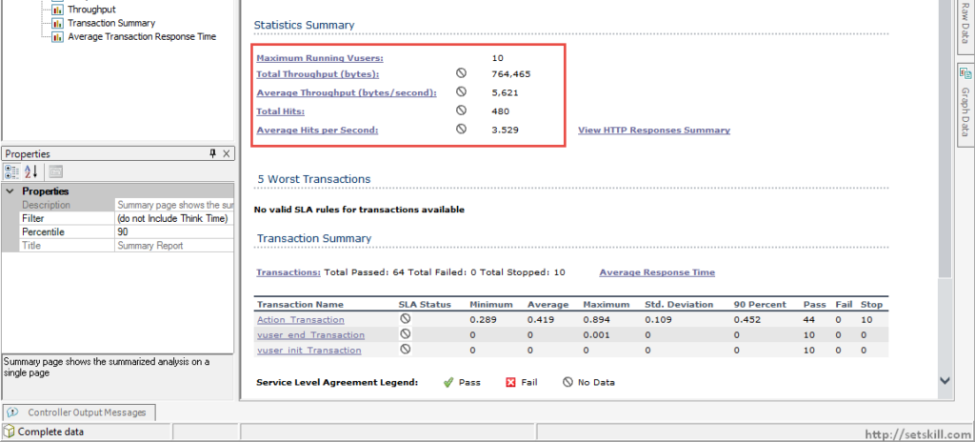

**SLA Summary**

If Service Level Agreements were defined in the Controller as part of the load test, they would be shown up here. Remember that in the previous section, we had defined an SLA for the 90%. The response time for that would be displayed here.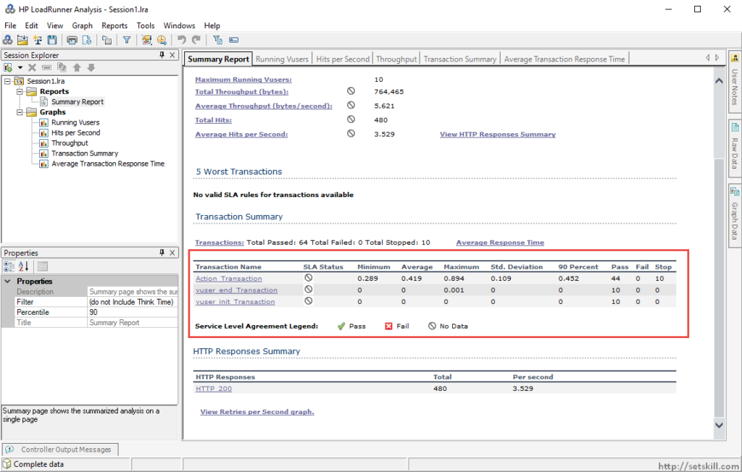

**Running VUsers**

This graph would give the number of Virtual users that were incremented during the course of the load test.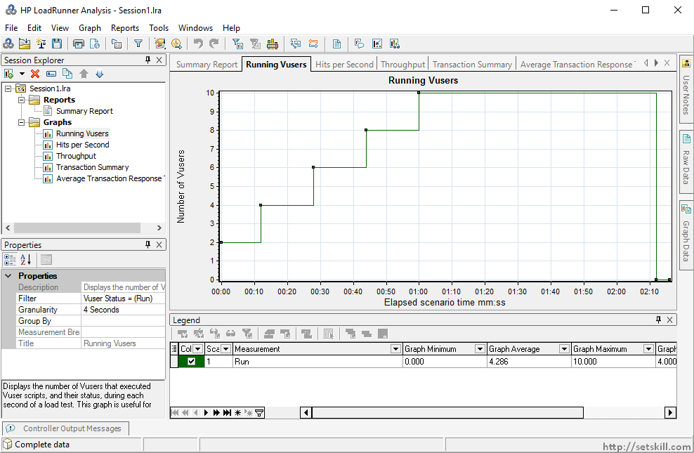

**Number of hits per second**

This graph would provide the number of hits by the load test against the application. This graph is good to see if the load test was consistent in hitting the application with requests at the right intervals.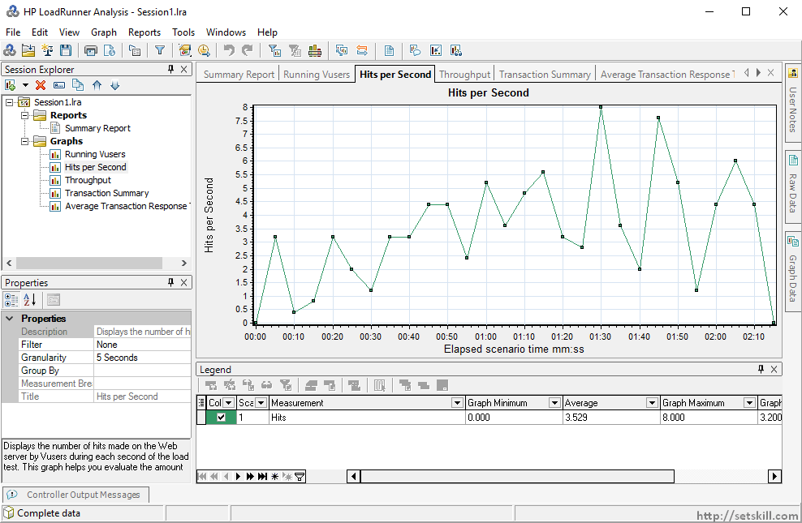

**Number of Bytes**

This graph would provide the number of bytes that was received by the Web server. This graph gives a good indication of the throughput of the application. If the throughput decreases as the user load increases then that can signal an issue in the application.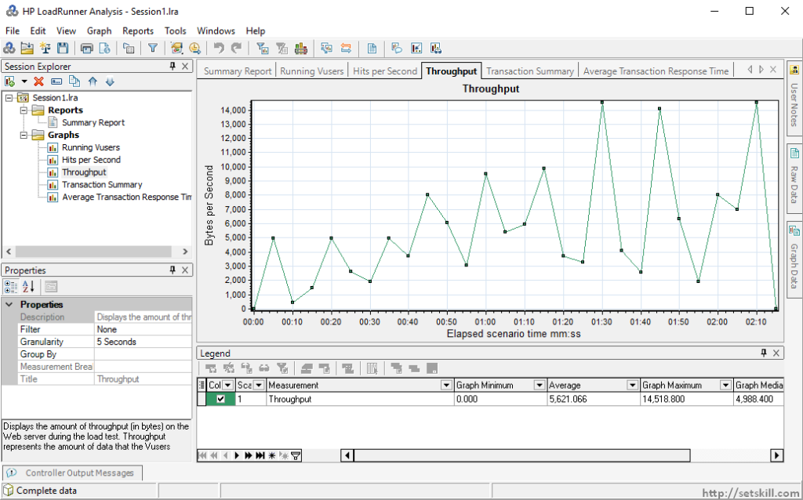

**Transaction Summary**

This chart is good in understanding the ratio of passed to failed transactions. The green bar represents the number of passed transactions and the orange one the number of failed transactions. So if you see a larger number of failed transactions, this would give an indication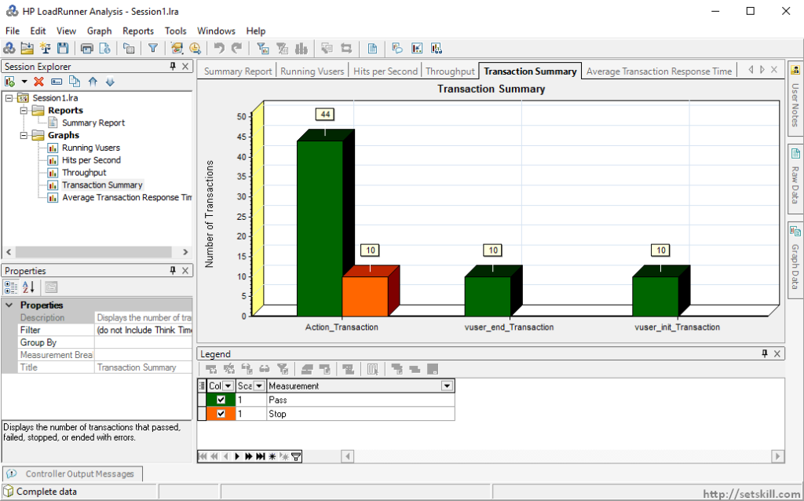

**Drilled Down Transaction Summary**

If you want to have a further drill down on the number of transactions per user, you can do so by using the drill down option available for the graph. To enable the drill down you need to right click on the graph and choose the Drill down option.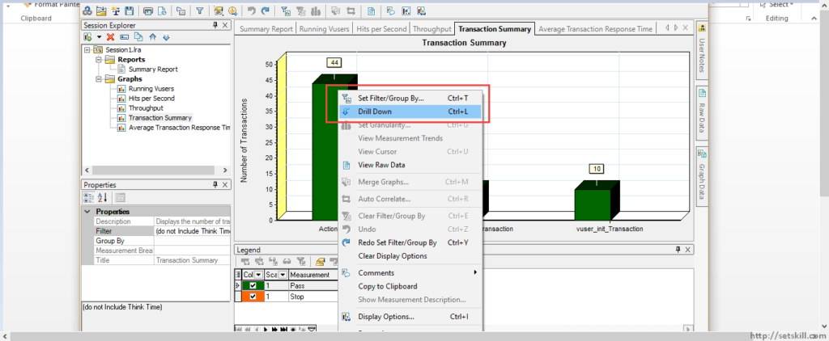  
Then in the next dialog box, ensure to choose the Group by to Virtual User ID.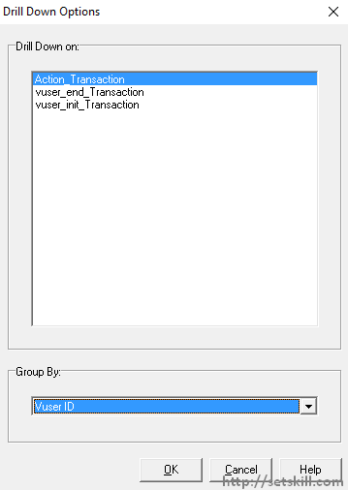

Once you click on the OK button, you will get the Transaction Summary by Virtual User.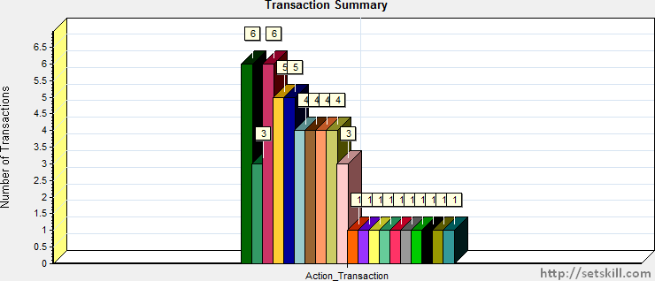

**Average Transaction Response time**

This graph gives the average transaction response time for all transactions executed by all users. This is a good graph to get an indication of how the application is performing. There can be a spike during the beginning of the load test in terms of response time, because initially the application needs time to scale its resources as per the load. But you should then start to see a gradual decrease and stabilization of the transaction response time. If you don’t then this can be an indication that there is an issue with the application.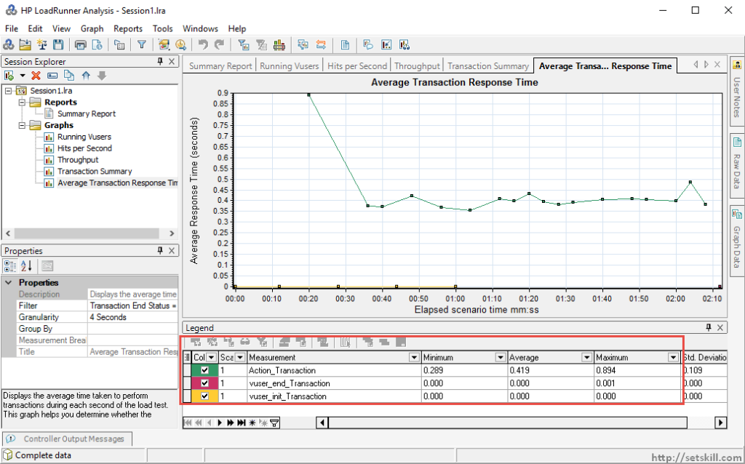  
If you want to see the Transaction Response time for all transactions, because the above graph just shows the ones for passed transactions, then you need to change the graph filter as shown below.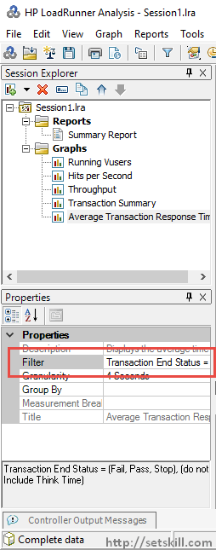

Then change the filter for Transaction End Status to include all possible type of transactions.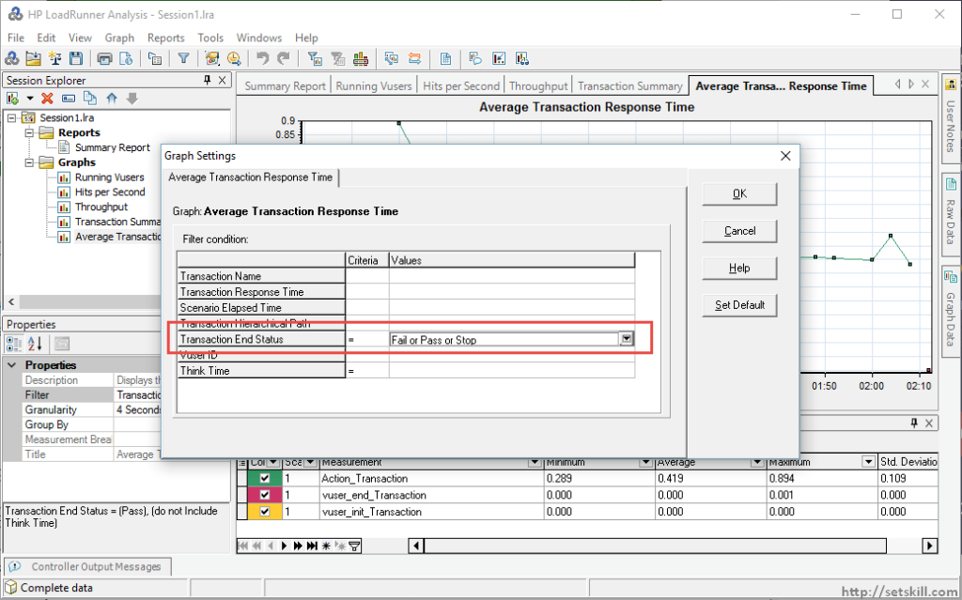

Once you do this, the graph will be updated to include all possible transactions.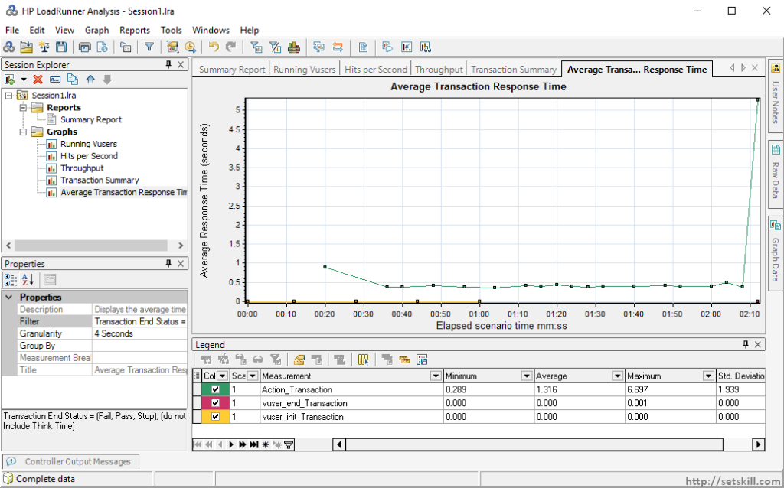

**Transaction summary per action**

If you want to view the transaction summary per Action, then you need to perform the following steps.  
Click on the Filter and Group option.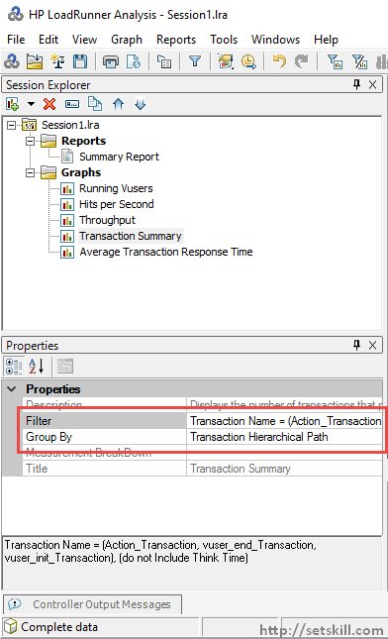

For the Filter option, choose the Transaction Name and ensure to choose all Action types available.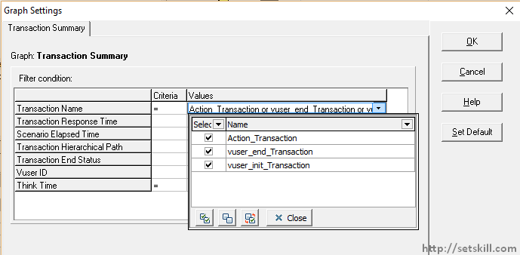

In the Group By filter, ensure that the selected groups has the “Transaction Hierarchical Path” chosen.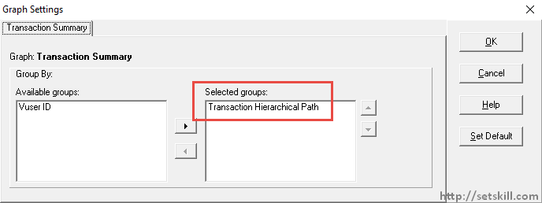

Once you enable the above options, you will then get the Transaction Summary per Action.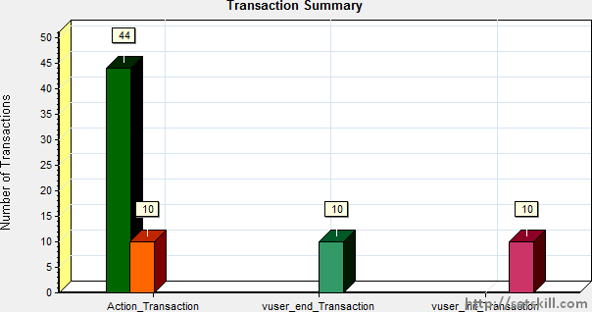

**HTTP Response per second**

If you want to see the HTTP Responses per second, you need to go to the Summary Screen and click the ‘HTTP 200’ link in the HTTP Response Summary section. The HTTP Responses should be consistent throughout the load test. If the responses starts to decrease even though the number of users is high, that would indicate that there is an issue with the application.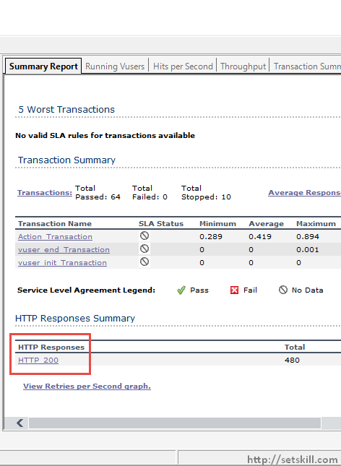  
You will then be presented with a detailed graph of the HTTP Responses per second.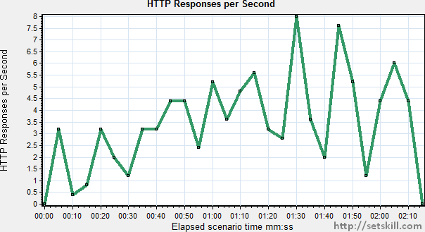

**Connection retries per second**

This is when the client has to re-establish a connection during the load test. This could be because the server has closed the connection or if the connection was refused from the server. If the number of re-tries is high that means there is an issue with the application.

You need to go to the Summary Screen and click the ‘View Retries per second graph’ option.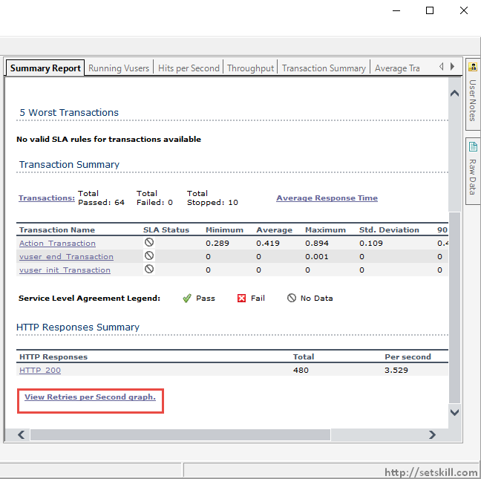

You will then be presented with a detailed graph of the number of Retries per second.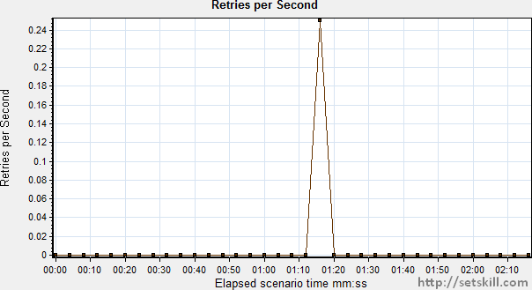

**Throughput (MB)**

This gives the amount of data received from the Web server during the load test.

Note: – If you cannot see this graph, then please follow the below steps to add a graph to the Analysis session. Click on the Menu option Graph > Add New Graph.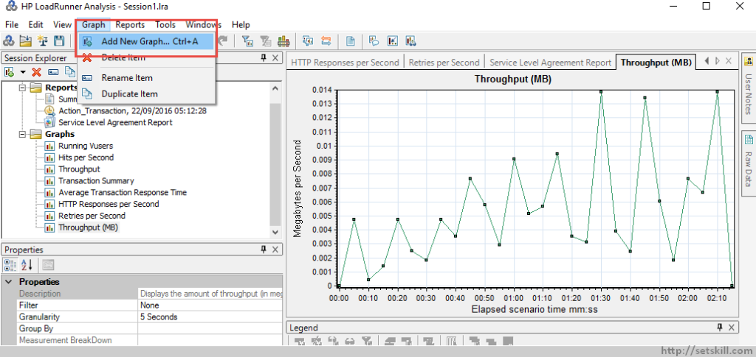

Then in the next Dialog box, select the desired graph and click on the button ‘Open Graph’.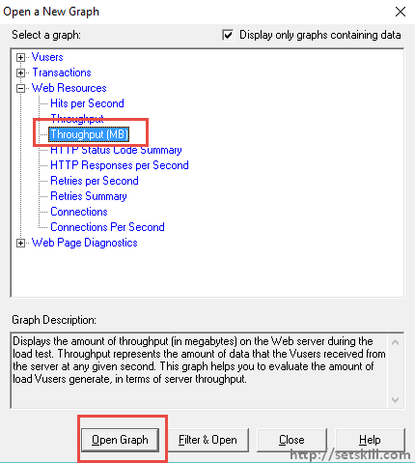

The throughput graph will then be visible in the Analysis.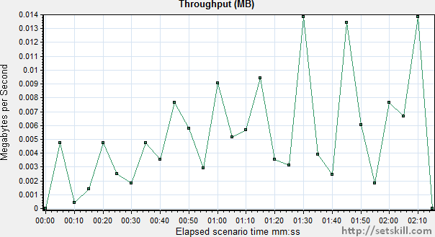

**Transaction response time (Percentile)**

This graph helps you understand whether your response time meet the accepted criteria.

The graph will then be displayed as shown below when you add this to the Analysis session.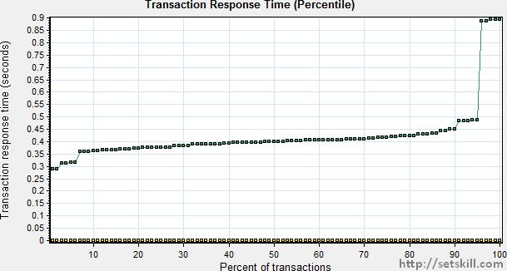

**Transaction Performance Summary**

This gives a summary of the minimum, average and maximum time of transactions in the load test.

The graph will then be displayed as shown below when you add this to the Analysis session.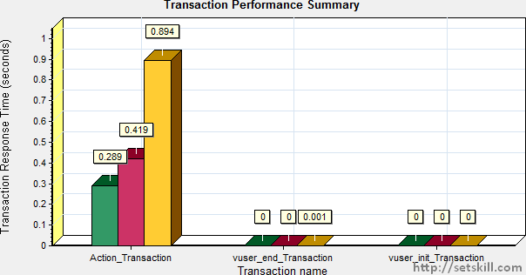

**Connections**

This graph gives the number of connections during the elapsed time of the load test. Obviously during the beginning of the load test, it should increase and decrease towards the end of the load test.

The graph will then be displayed as shown below when you add this to the Analysis session.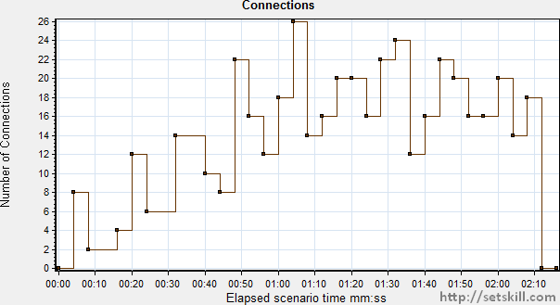

**Connections per second**

This graph gives the number of new connections and the number of connections which were shut down during the course of the load test.

The graph will then be displayed as shown below when you add this to the Analysis session.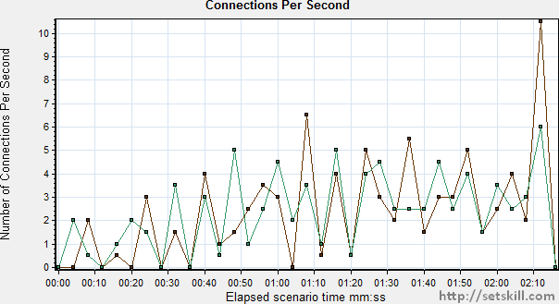

**Page Component breakdown**

This is a useful graph for finding any response time issues per page. In this the response time for each page over the duration of the load test is provided.

The graph will then be displayed as shown below when you add this to the Analysis session.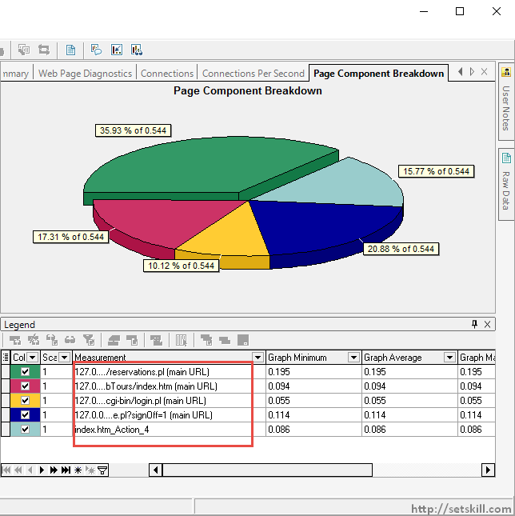

**Page Download time**

This graph gives the time each page took to download from the server. If the time is high, then this is a cause of concern for the application.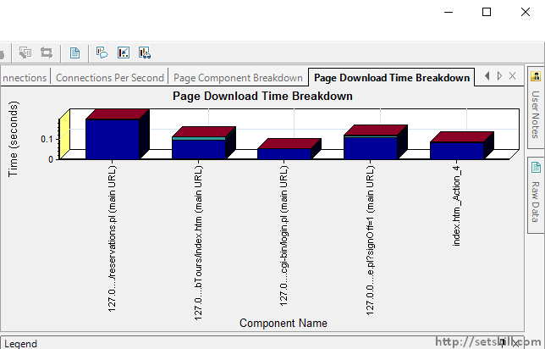

**How to view the scenario settings**

If you want to know what are the run settings which were used in the Controller for the load test, you can do that in the Analysis as well. Sometimes you may open an existing session file and want to know what the scenario settings used in the load test were.

Use the file menu option of File > View Scenario Runtime settings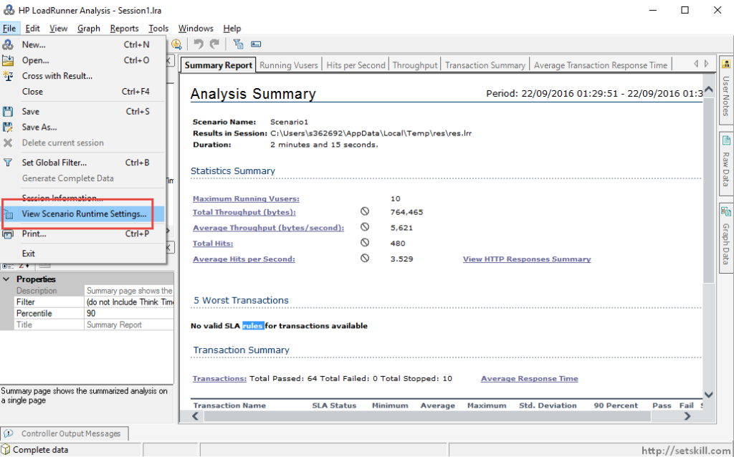

Once you do this, you will get the below screen which will provide details on the Run Scenario settings. If you click on the Scenario Schedule, you will get the required details about the Schedule which was used in the Controller module.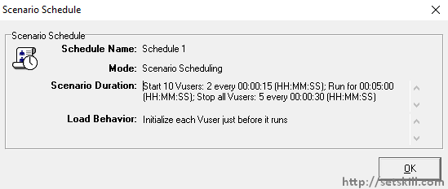

**How to export results to HTML**

The results in the Analysis can also be exported to HTML if required. To export the results to HTML, follow the below steps. Click on the file menu option of Reports->HTML Report.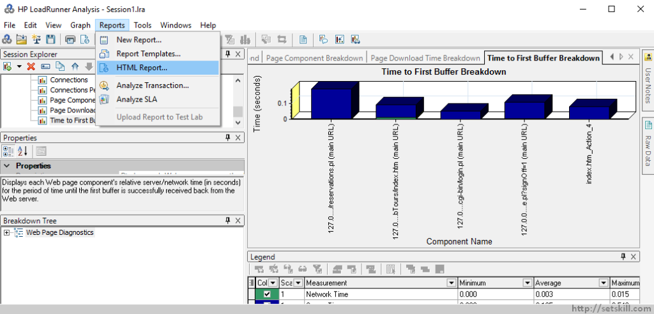

You can actually see the progress of the report being generated.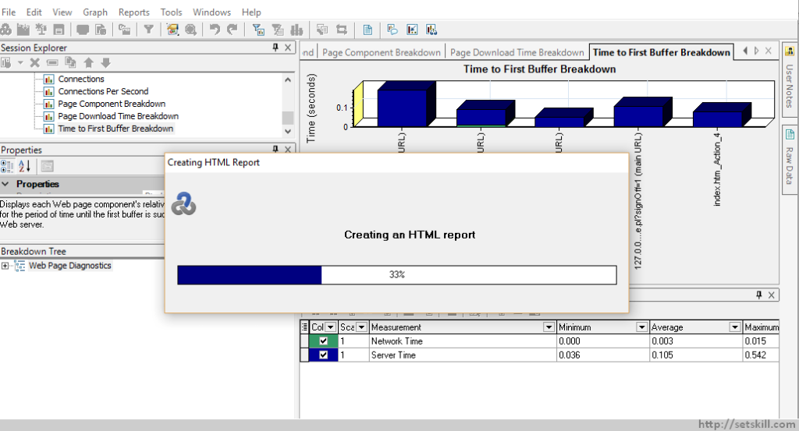

You will then be able to see the HTML Report in the browser.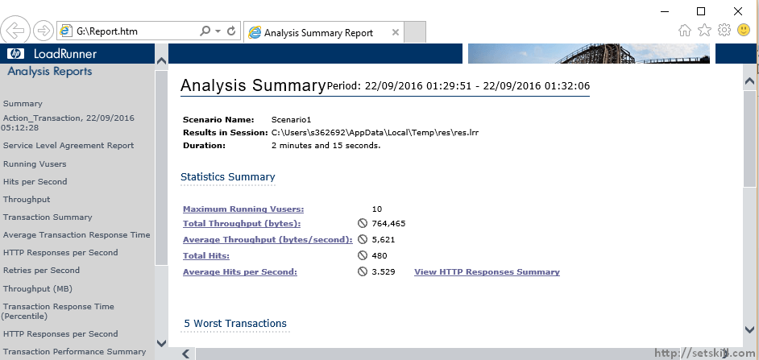

**How to merge graphs**

Merging graphs can be useful when you want to view the information in 2 graphs at the same time. This can be useful for comparing results. Ensure that when you are merging graphs that at least one graph is open.

Let’s choose the Hits per second graph and then choose the Merge Graphs option from the Context menu.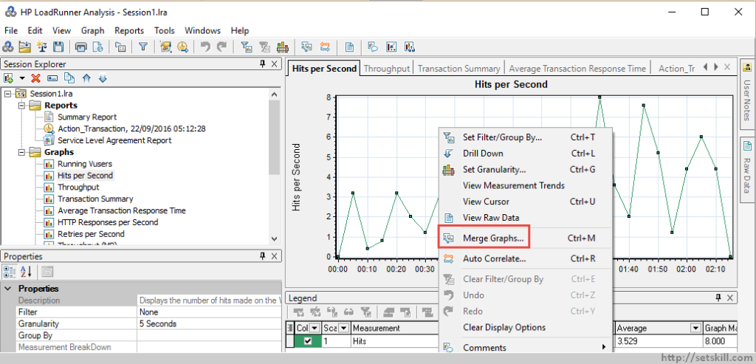

Then choose the option to merge the graph with the Running VUsers and then click the OK button.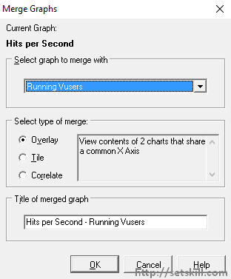

You will then get the complete picture of the number of hits per second as per the virtual users. The sample result is shown below.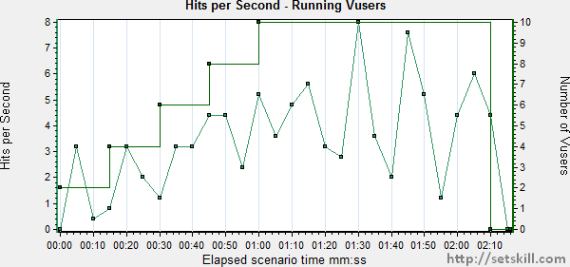

**How to save a session**

To save an Analysis session, you can do this from the file menu.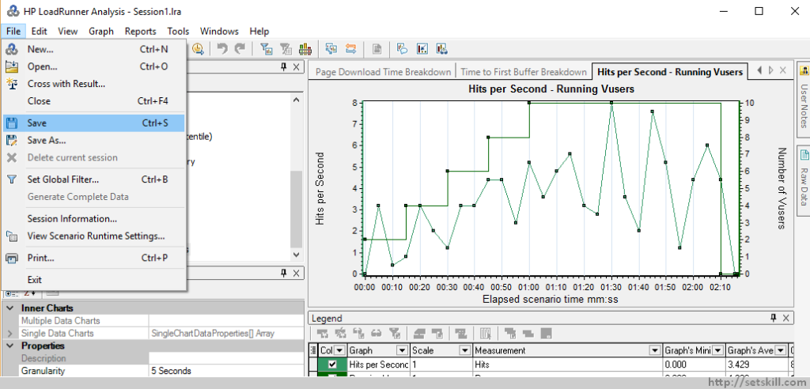

In the dialog box, choose the location and enter a name for the session and then click the Save button.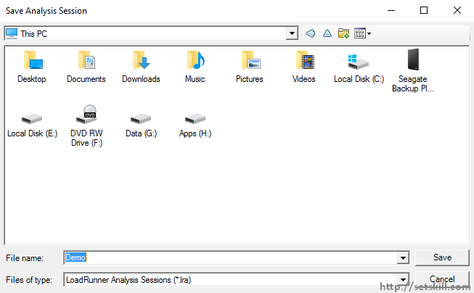

**How to open an existing session**

To open an existing Analysis session, you can do this from the file menu.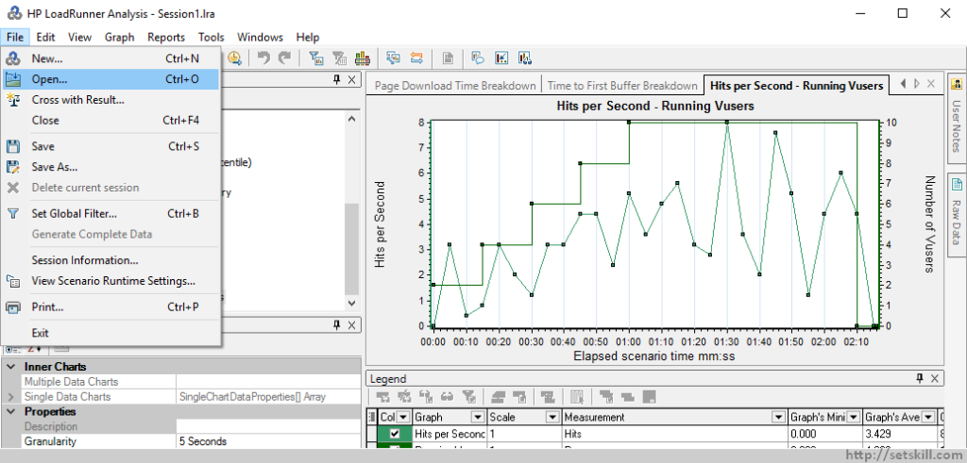

Then go to the desired file location and choose the required analysis session file.